**Program 1: Genetic Algorithm for Optimization on Problems**

**Algorithm:**

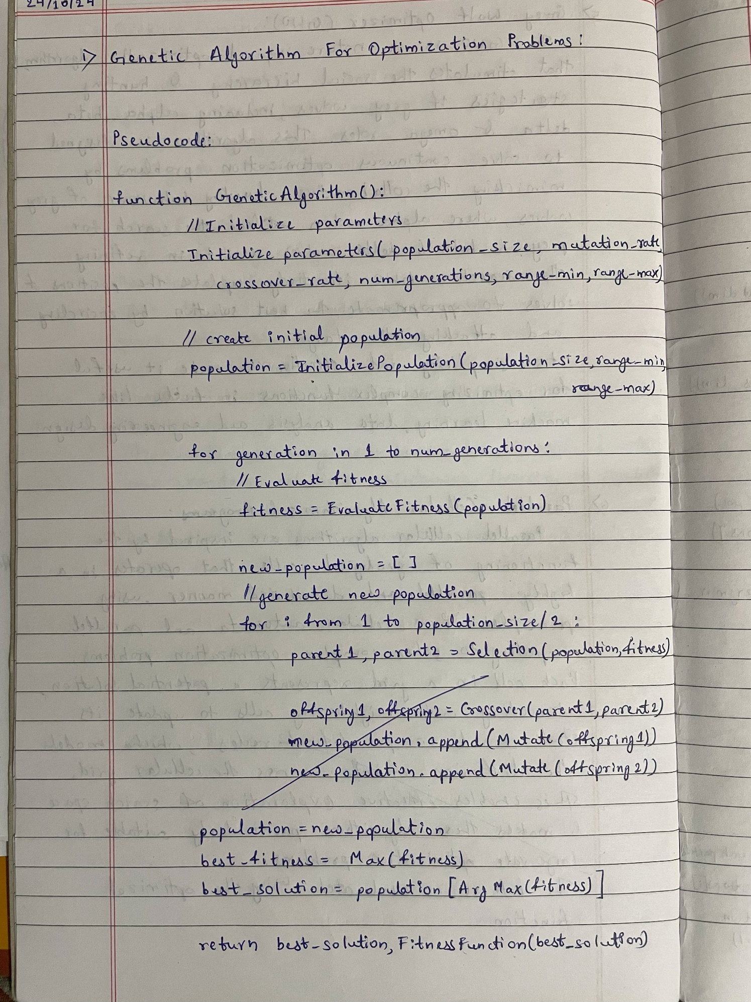

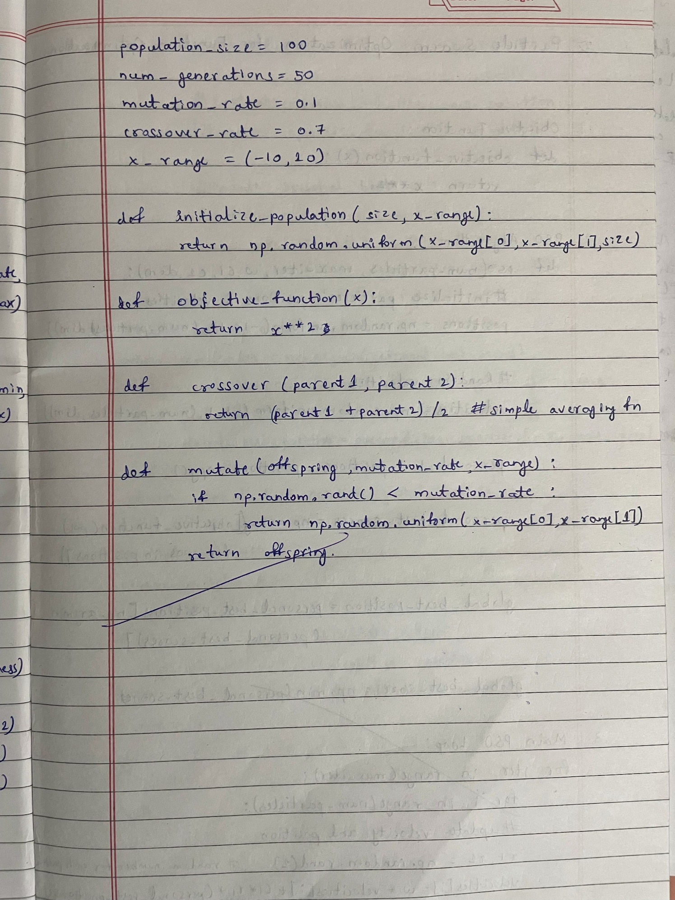

**Code:**

#lab-2: genetic

import numpy as np

import random

# Objective function to maximize

def objective_function(x):

    return x ** 2

# Initialize parameters

population_size = 100

num_generations = 50

mutation_rate = 0.1

crossover_rate = 0.7

range_min = -10

range_max = 10

# Create initial population

def initialize_population(size, min_val, max_val):

    return np.random.uniform(min_val, max_val, size)

# Evaluate fitness of the population

def evaluate_fitness(population):

    return np.array([objective_function(x) for x in population])

# Selection using roulette-wheel method

def selection(population, fitness):

    total_fitness = np.sum(fitness)

    probabilities = fitness / total_fitness

    return population[np.random.choice(range(len(population)), size=2, p=probabilities)]

# Crossover between two parents

def crossover(parent1, parent2):

    if random.random() < crossover_rate:

        return (parent1 + parent2) / 2  # Simple averaging for crossover

    return parent1  # No crossover

# Mutation of an individual

def mutate(individual):

    if random.random() < mutation_rate:

        return np.random.uniform(range_min, range_max)

    return individual

# Genetic Algorithm function

def genetic_algorithm():

    # Step 1: Initialize population

    population = initialize_population(population_size, range_min, range_max)

    for generation in range(num_generations):

        # Step 2: Evaluate fitness

        fitness = evaluate_fitness(population)

        # Track the best solution

        best_index = np.argmax(fitness)

        best_solution = population[best_index]

        best_fitness = fitness[best_index]

        # print(f"Generation {generation + 1}: Best Solution = {best_solution}, Fitness = {best_fitness}")

        # Step 3: Create new population

        new_population = []

        for _ in range(population_size):

            # Select parents

            parent1, parent2 = selection(population, fitness)

            # Crossover to create offspring

            offspring = crossover(parent1, parent2)

            # Mutate offspring

            offspring = mutate(offspring)

            new_population.append(offspring)

        # Step 6: Replace old population with new population

        population = np.array(new_population)

    return best_solution, best_fitness

# Run the Genetic Algorithm

best_solution, best_fitness = genetic_algorithm()

print(f"Best Solution Found: {best_solution}, Fitness: {best_fitness}")

OUTPUT:



**Program 2: Particle Swarm Optimization for Function Optimization**

**Algorithm:**

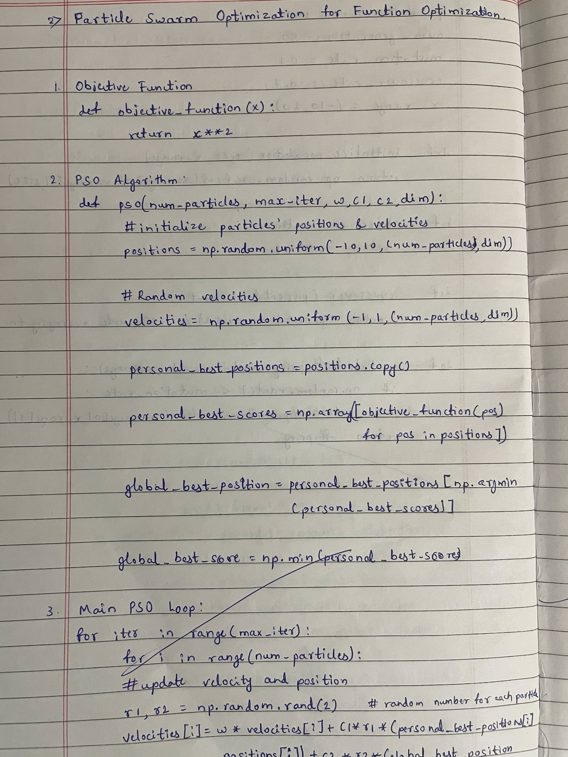

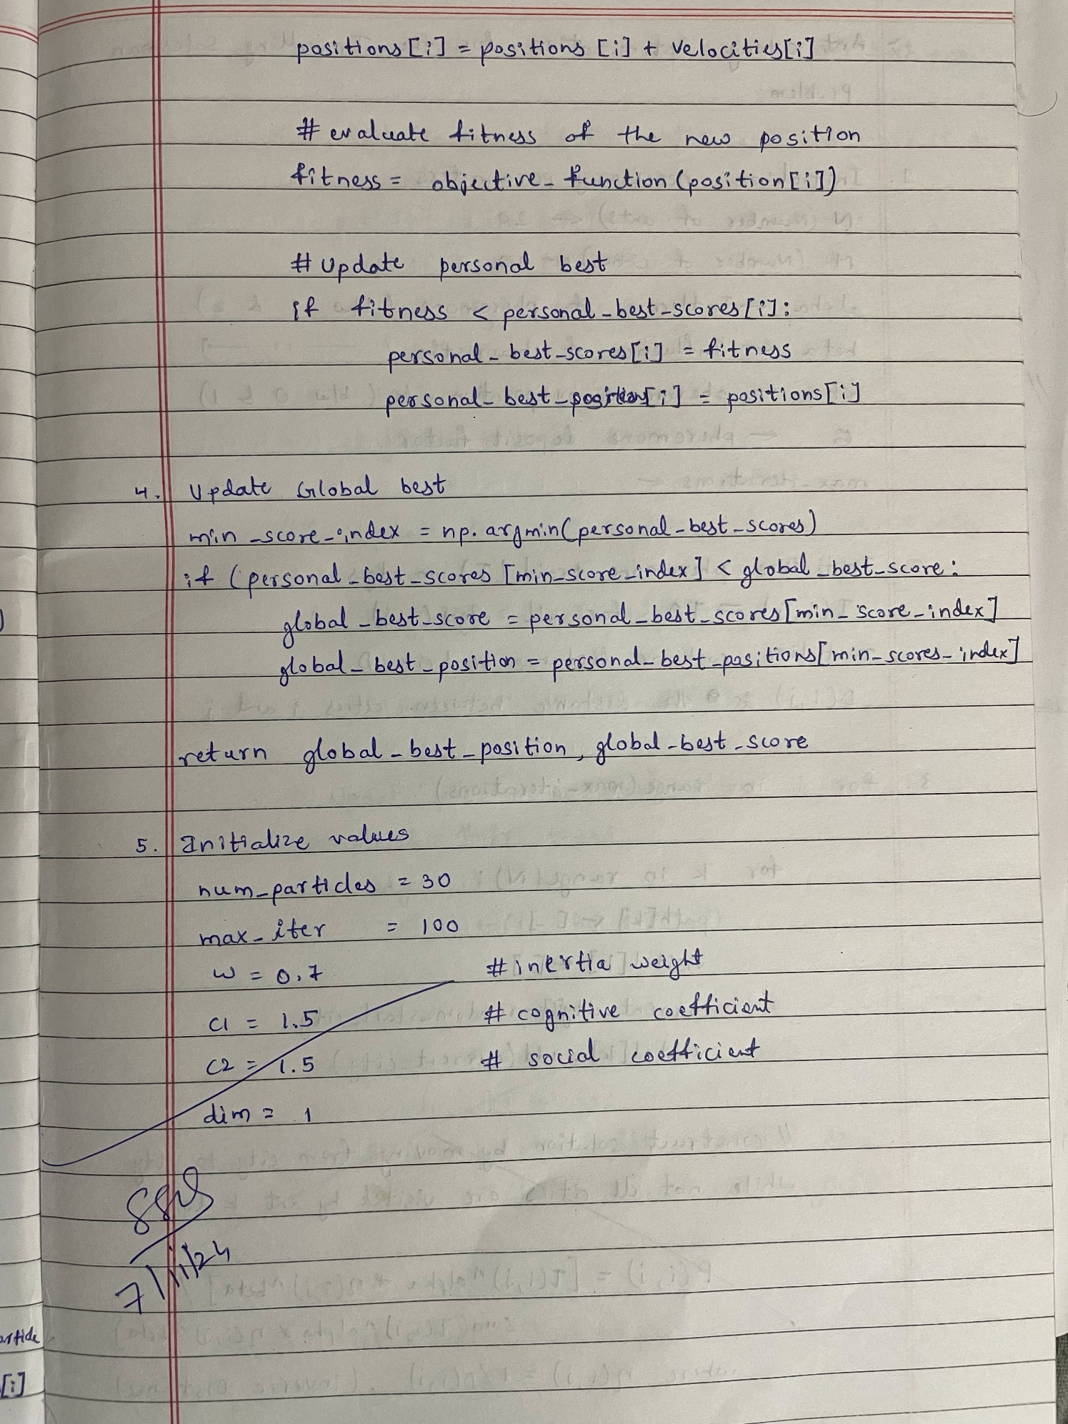

**Code:**

#lab-3: pso

import numpy as np

import random

# Define the optimization problem (Rastrigin Function)

def rastrigin(x):

    A = 10

    return A * len(x) + sum([(xi**2 - A * np.cos(2 * np.pi * xi)) for xi in x])

# Particle Swarm Optimization (PSO) implementation

class Particle:

    def __init__(self, dimension, lower_bound, upper_bound):

        # Initialize the particle position and velocity randomly

        self.position = np.random.uniform(lower_bound, upper_bound, dimension)

        self.velocity = np.random.uniform(-1, 1, dimension)

        self.best_position = np.copy(self.position)

        self.best_value = rastrigin(self.position)

    def update_velocity(self, global_best_position, w, c1, c2):

        # Update the velocity of the particle

        r1 = np.random.rand(len(self.position))

        r2 = np.random.rand(len(self.position))

        # Inertia term

        inertia = w * self.velocity

        # Cognitive term (individual best)

        cognitive = c1 * r1 * (self.best_position - self.position)

        # Social term (global best)

        social = c2 * r2 * (global_best_position - self.position)

        # Update velocity

        self.velocity = inertia + cognitive + social

    def update_position(self, lower_bound, upper_bound):

        # Update the position of the particle

        self.position = self.position + self.velocity

        # Ensure the particle stays within the bounds

        self.position = np.clip(self.position, lower_bound, upper_bound)

    def evaluate(self):

        # Evaluate the fitness of the particle

        fitness = rastrigin(self.position)

        # Update the particle's best position if necessary

        if fitness < self.best_value:

            self.best_value = fitness

            self.best_position = np.copy(self.position)

def particle_swarm_optimization(dim, lower_bound, upper_bound, num_particles=30, max_iter=100, w=0.5, c1=1.5, c2=1.5):

    # Initialize particles

    particles = [Particle(dim, lower_bound, upper_bound) for _ in range(num_particles)]

    # Initialize the global best position and value

    global_best_position = particles[0].best_position

    global_best_value = particles[0].best_value

    for i in range(max_iter):

        # Update each particle

        for particle in particles:

            particle.update_velocity(global_best_position, w, c1, c2)

            particle.update_position(lower_bound, upper_bound)

            particle.evaluate()

            # Update global best position if needed

            if particle.best_value < global_best_value:

                global_best_value = particle.best_value

                global_best_position = np.copy(particle.best_position)

        # Optionally print the progress

        if (i+1 ) % 10 == 0:

            print(f"Iteration {i+1 }/{max_iter} - Best Fitness: {global_best_value}")

    return global_best_position, global_best_value

# Set the parameters for the PSO algorithm

dim = 2                # Number of dimensions for the function

lower_bound = -5.12    # Lower bound of the search space

upper_bound = 5.12     # Upper bound of the search space

num_particles = 30     # Number of particles in the swarm

max_iter = 100         # Number of iterations

# Run the PSO

best_position, best_value = particle_swarm_optimization(dim, lower_bound, upper_bound, num_particles, max_iter)

# Output the best solution found

print("\nBest Solution Found:")

print("Position:", best_position)

print("Fitness:", best_value)

OUTPUT:

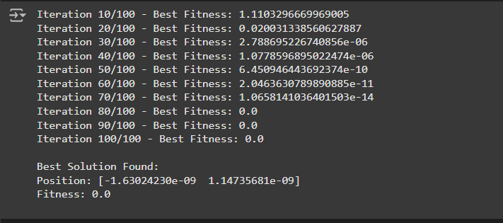

**Program 3: Ant Colony Optimization for the Traveling Salesman Problem**

**Algorithm:**

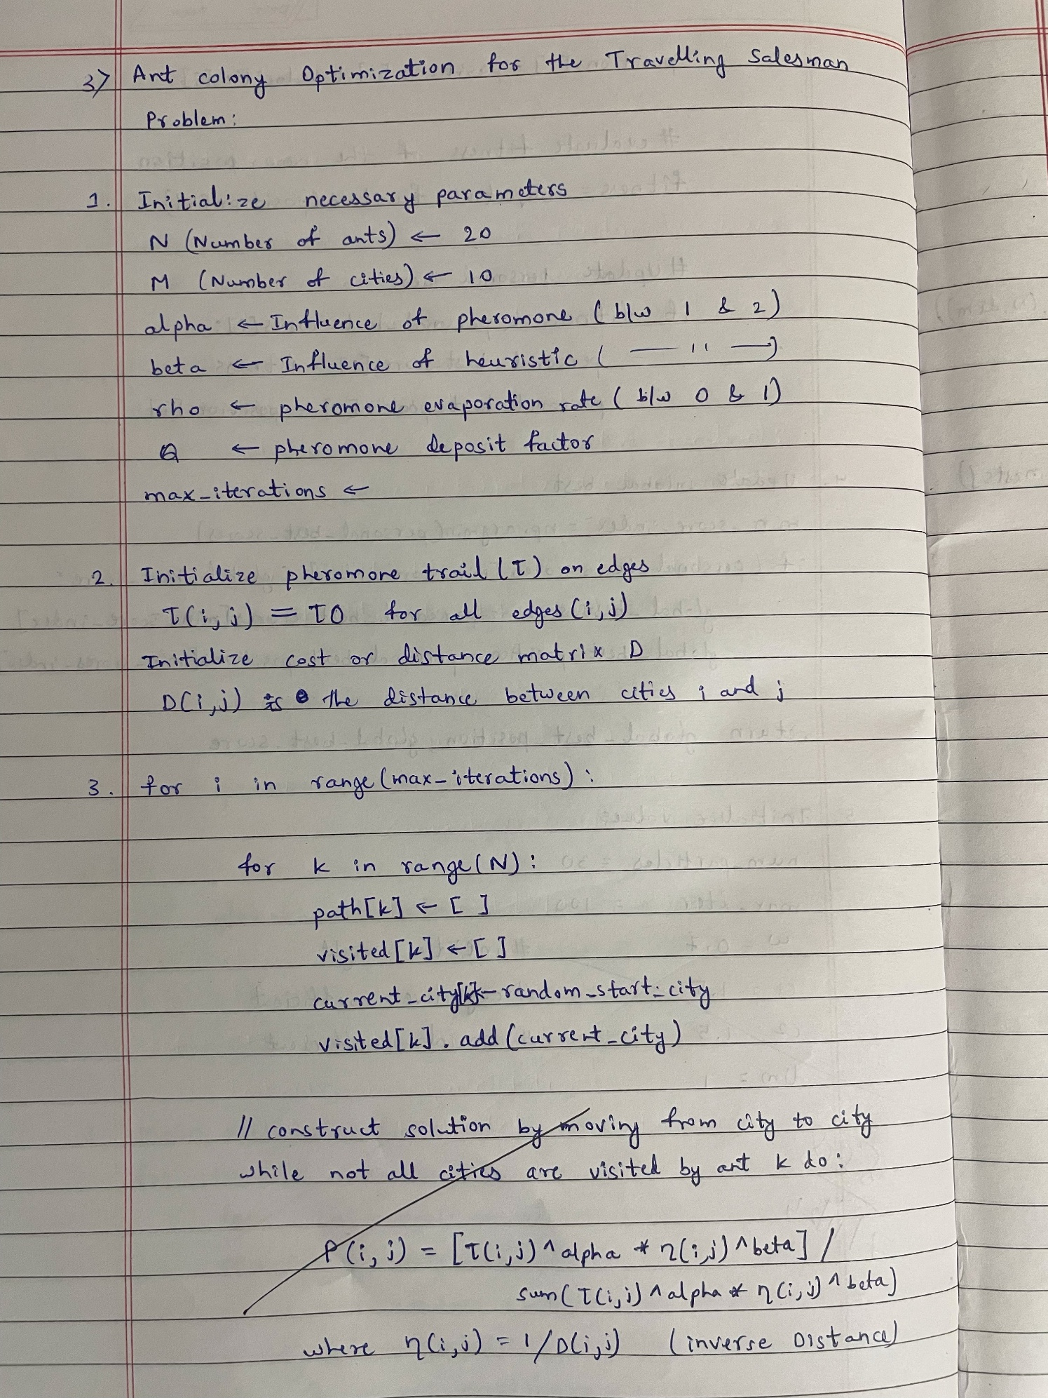

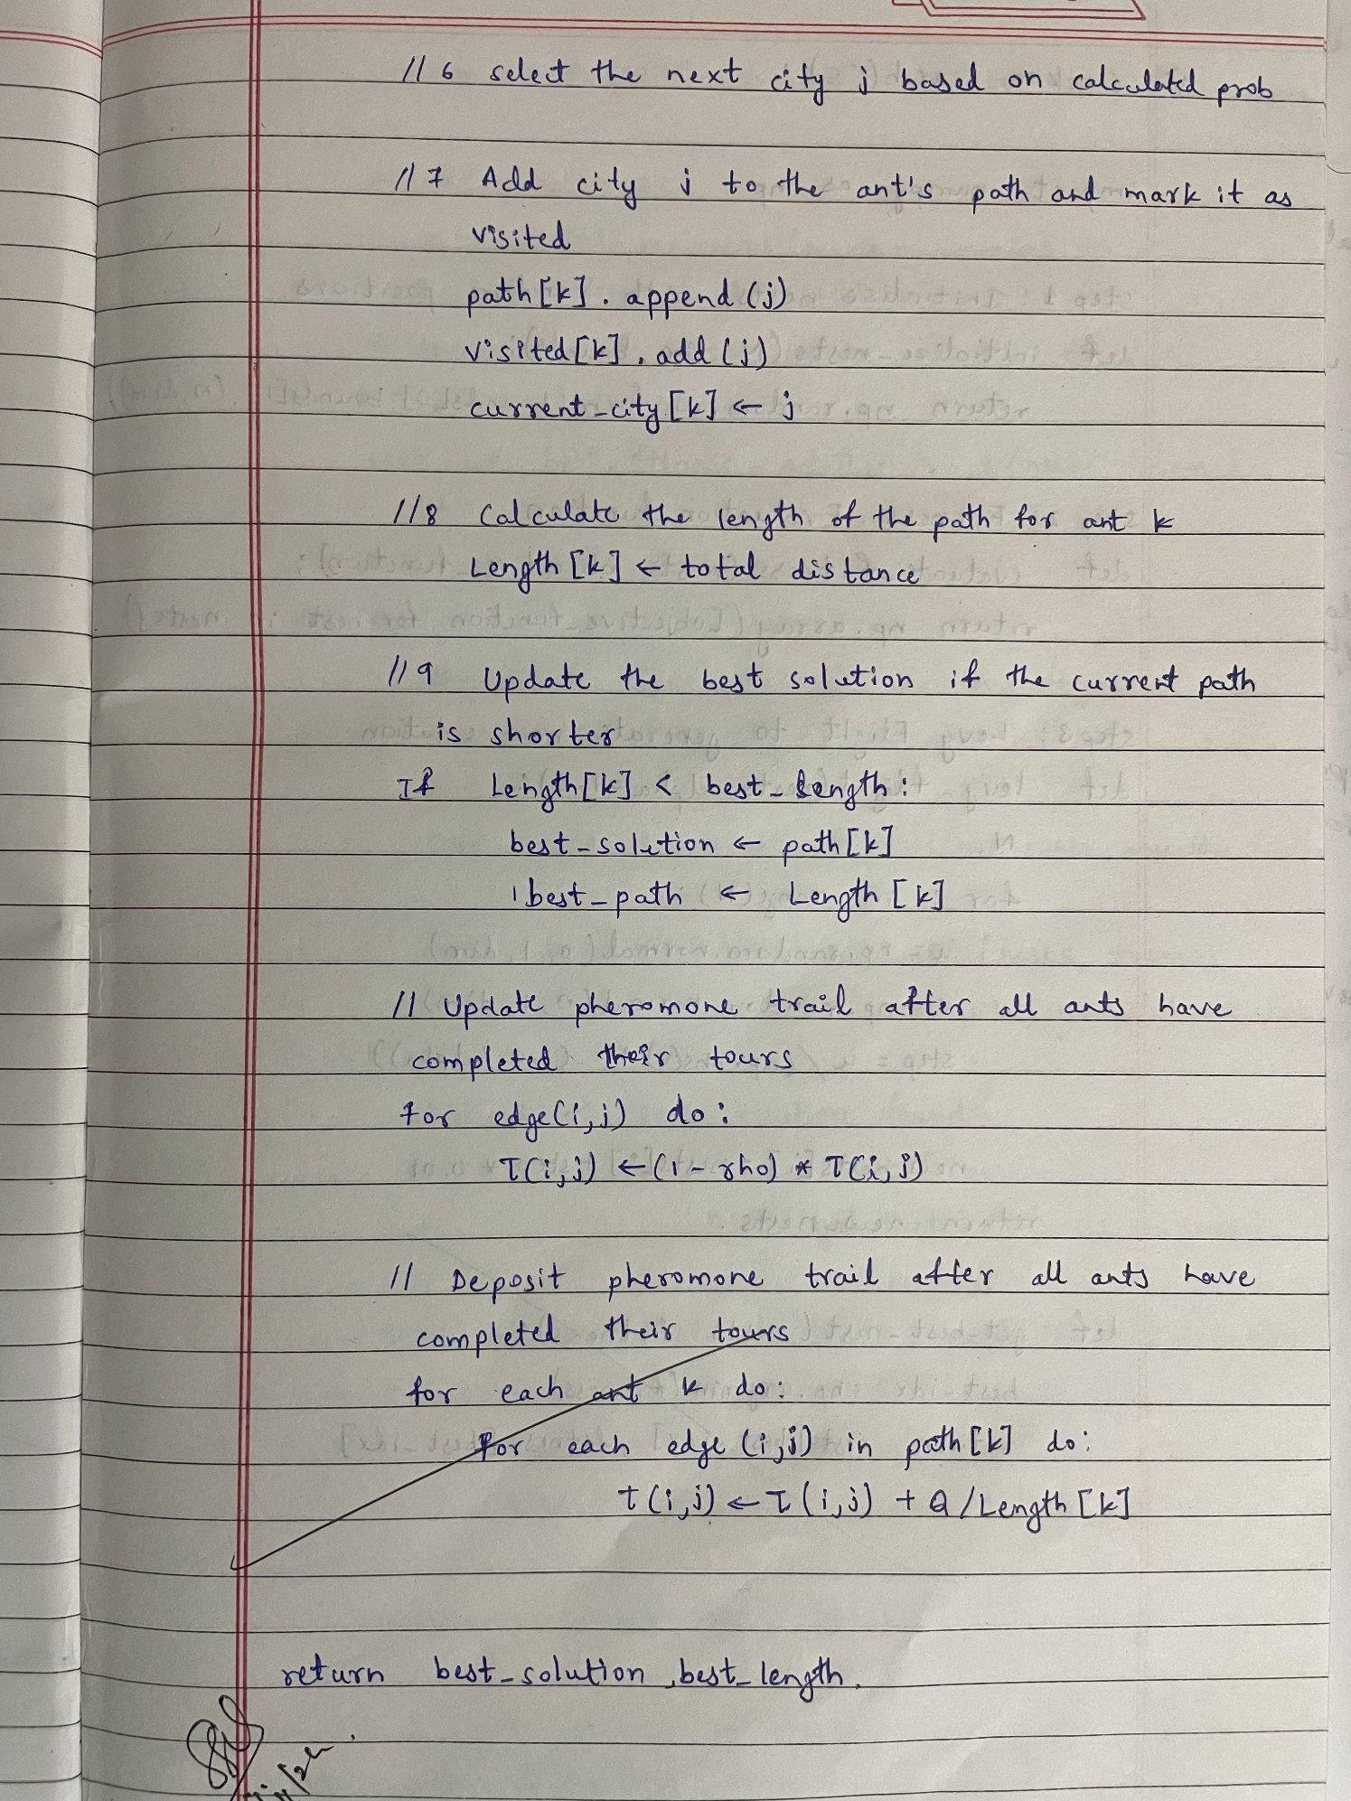

**Code:**

#ant colony

import numpy as np

import matplotlib.pyplot as plt

# 1. Define the Problem: Create a set of cities with their coordinates

cities = np.array([

    [0, 0],  # City 0

    [1, 5],  # City 1

    [5, 1],  # City 2

    [6, 4],  # City 3

    [7, 8],  # City 4

])

# Calculate the distance matrix between each pair of cities

def calculate_distances(cities):

    num_cities = len(cities)

    distances = np.zeros((num_cities, num_cities))

    for i in range(num_cities):

        for j in range(num_cities):

            distances[i][j] = np.linalg.norm(cities[i] - cities[j])

    return distances

distances = calculate_distances(cities)

# 2. Initialize Parameters

num_ants = 10

num_cities = len(cities)

alpha = 1.0  # Influence of pheromone

beta = 5.0   # Influence of heuristic (inverse distance)

rho = 0.5    # Evaporation rate

num_iterations = 30

initial_pheromone = 1.0

# Pheromone matrix initialization

pheromone = np.ones((num_cities, num_cities)) * initial_pheromone

# 3. Heuristic information (Inverse of distance)

def heuristic(distances):

    with np.errstate(divide='ignore'):  # Ignore division by zero

        return 1 / distances

eta = heuristic(distances)

# 4. Choose next city probabilistically based on pheromone and heuristic info

def choose_next_city(pheromone, eta, visited):

    probs = []

    for j in range(num_cities):

        if j not in visited:

            pheromone_ij = pheromone[visited[-1], j] ** alpha

            heuristic_ij = eta[visited[-1], j] ** beta

            probs.append(pheromone_ij * heuristic_ij)

        else:

            probs.append(0)

    probs = np.array(probs)

    return np.random.choice(range(num_cities), p=probs / probs.sum())

# Construct solution for a single ant

def construct_solution(pheromone, eta):

    tour = [np.random.randint(0, num_cities)]

    while len(tour) < num_cities:

        next_city = choose_next_city(pheromone, eta, tour)

        tour.append(next_city)

    return tour

# 5. Update pheromones after all ants have constructed their tours

def update_pheromones(pheromone, all_tours, distances, best_tour):

    pheromone *= (1 - rho)  # Evaporate pheromones

    # Add pheromones for each ant's tour

    for tour in all_tours:

        tour_length = sum([distances[tour[i], tour[i + 1]] for i in range(-1, num_cities - 1)])

        for i in range(-1, num_cities - 1):

            pheromone[tour[i], tour[i + 1]] += 1.0 / tour_length

    # Increase pheromones on the best tour

    best_length = sum([distances[best_tour[i], best_tour[i + 1]] for i in range(-1, num_cities - 1)])

    for i in range(-1, num_cities - 1):

        pheromone[best_tour[i], best_tour[i + 1]] += 1.0 / best_length

# 6. Main ACO Loop: Iterate over multiple iterations to find the best solution

def run_aco(distances, num_iterations):

    pheromone = np.ones((num_cities, num_cities)) * initial_pheromone

    best_tour = None

    best_length = float('inf')

    for iteration in range(num_iterations):

        all_tours = [construct_solution(pheromone, eta) for _ in range(num_ants)]

        all_lengths = [sum([distances[tour[i], tour[i + 1]] for i in range(-1, num_cities - 1)]) for tour in all_tours]

        current_best_length = min(all_lengths)

        current_best_tour = all_tours[all_lengths.index(current_best_length)]

        if current_best_length < best_length:

            best_length = current_best_length

            best_tour = current_best_tour

        update_pheromones(pheromone, all_tours, distances, best_tour)

        print(f"Iteration {iteration + 1}, Best Length: {best_length}")

    return best_tour, best_length

# Run the ACO algorithm

best_tour, best_length = run_aco(distances, num_iterations)

# 7. Output the Best Solution

print(f"Best Tour: {best_tour}")

print(f"Best Tour Length: {best_length}")

# 8. Plot the Best Route

def plot_route(cities, best_tour):

    plt.figure(figsize=(8, 6))

    for i in range(len(cities)):

        plt.scatter(cities[i][0], cities[i][1], color='red')

        plt.text(cities[i][0], cities[i][1], f"City {i}", fontsize=12)

    # Plot the tour as lines connecting the cities

    tour_cities = np.array([cities[i] for i in best_tour] + [cities[best_tour[0]]])  # Complete the loop by returning to the start

    plt.plot(tour_cities[:, 0], tour_cities[:, 1], linestyle='-', marker='o', color='blue')

    plt.title(f"Best Tour (Length: {best_length})")

    plt.xlabel("X Coordinate")

    plt.ylabel("Y Coordinate")

    plt.grid(True)

    plt.show()

# Call the plot function

plot_route(cities, best_tour)

OUTPUT:

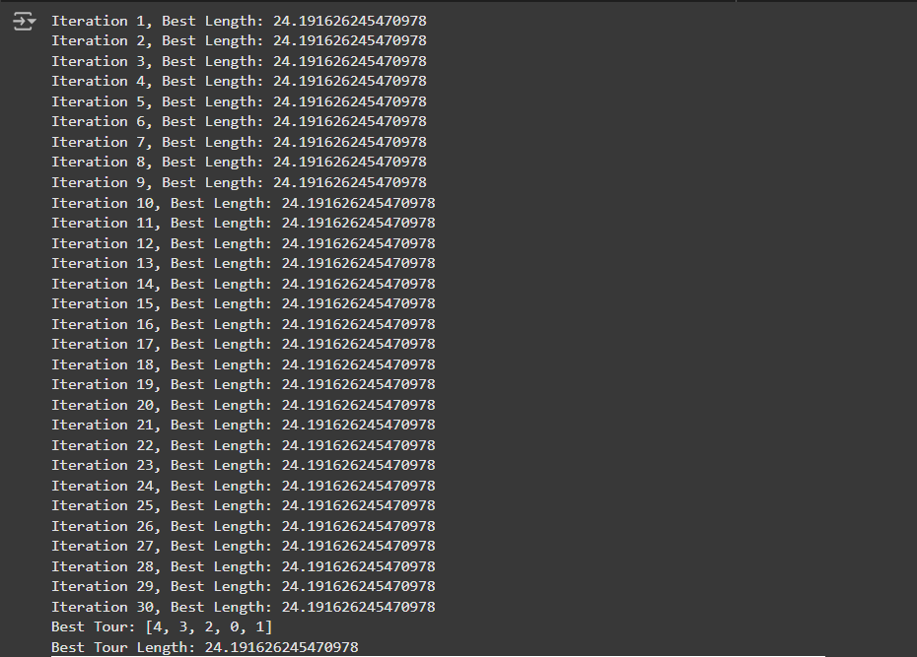

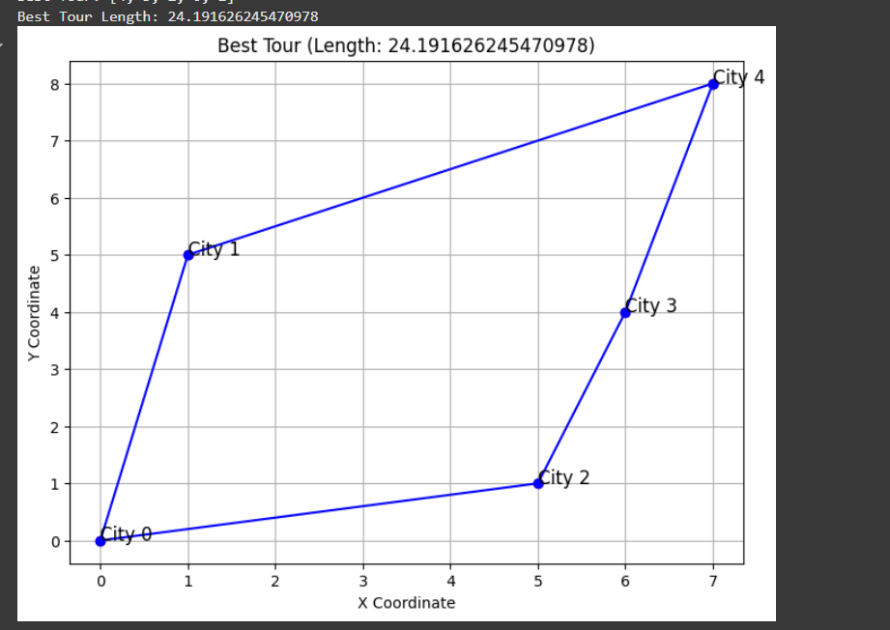

**Program 4: Cuckoo Search (CS)**

**Algorithm:**

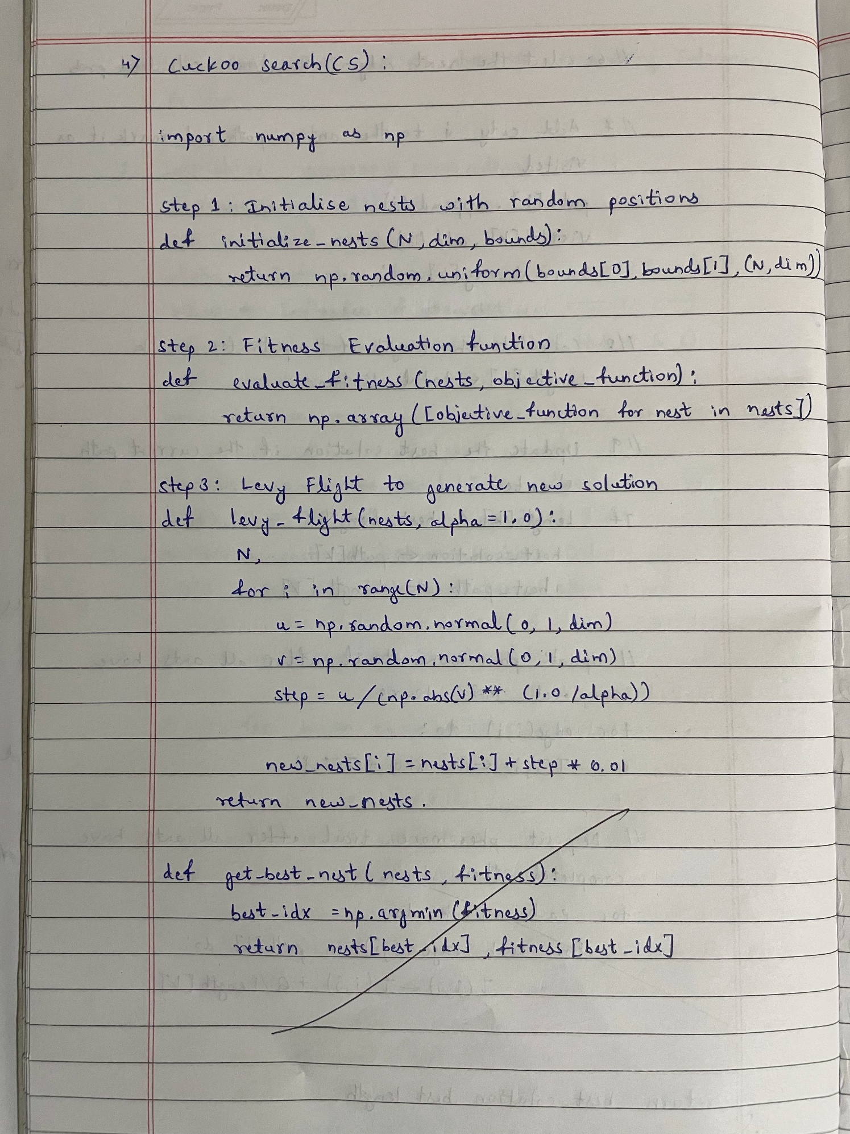

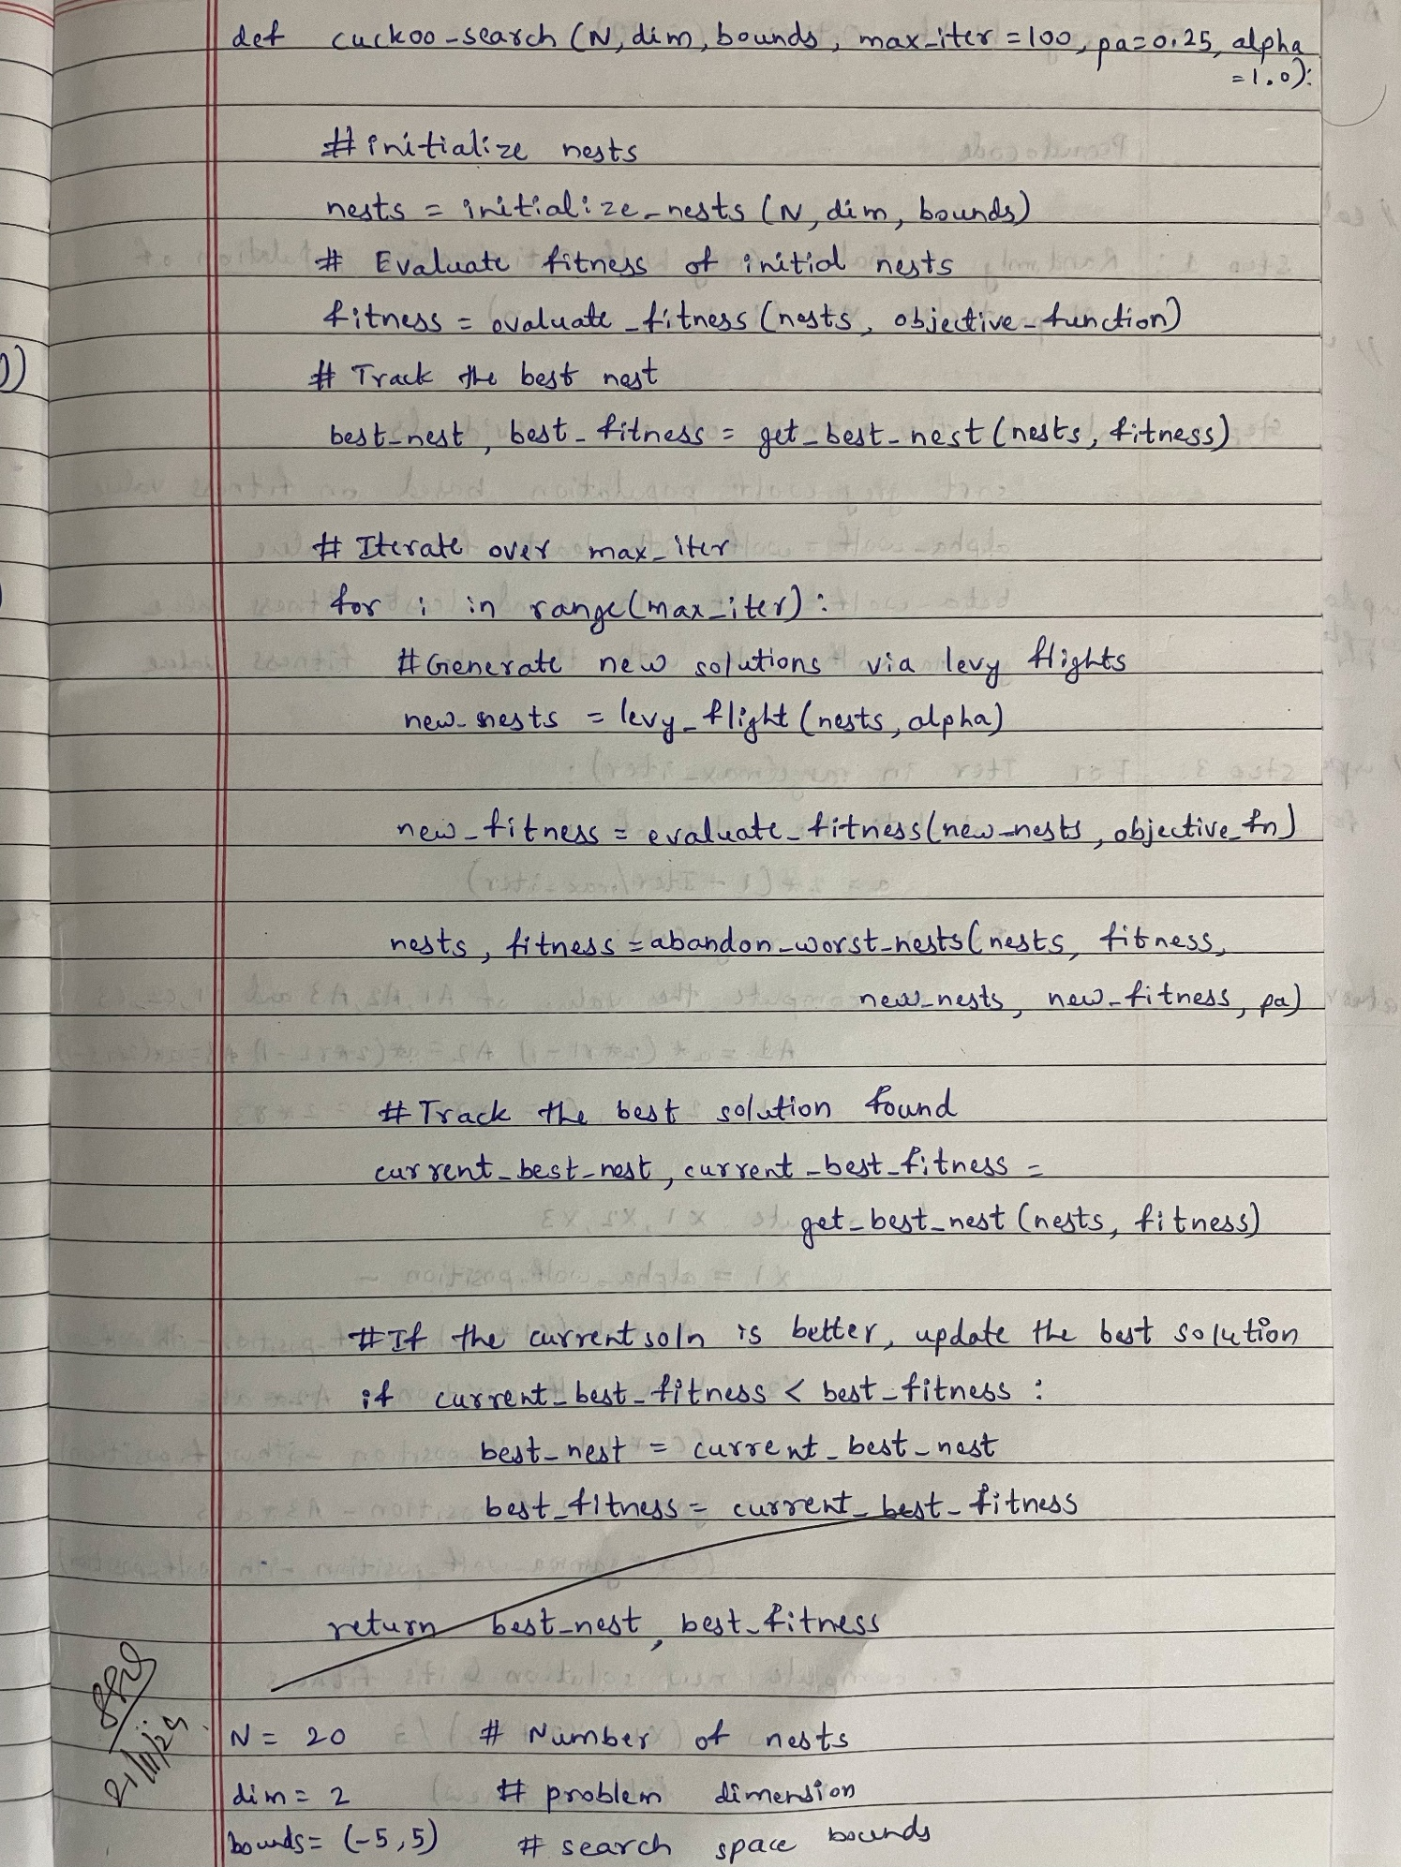

**Code:**

#cuckoo search

import numpy as np

import random

import math

import matplotlib.pyplot as plt

# Define a sample function to optimize (Sphere function in this case)

def objective_function(x):

    return np.sum(x ** 2)

# Lévy flight function

def levy_flight(Lambda):

    sigma_u = (math.gamma(1 + Lambda) * np.sin(np.pi * Lambda / 2) /

               (math.gamma((1 + Lambda) / 2) * Lambda * 2 ** ((Lambda - 1) / 2))) ** (1 / Lambda)

    sigma_v = 1

    u = np.random.normal(0, sigma_u, size=1)

    v = np.random.normal(0, sigma_v, size=1)

    step = u / (abs(v) ** (1 / Lambda))

    return step

# Cuckoo Search algorithm

def cuckoo_search(num_nests=25, num_iterations=100, discovery_rate=0.25, dim=5, lower_bound=-10, upper_bound=10):

    # Initialize nests

    nests = np.random.uniform(lower_bound, upper_bound, (num_nests, dim))

    fitness = np.array([objective_function(nest) for nest in nests])

    # Get the current best nest

    best_nest_idx = np.argmin(fitness)

    best_nest = nests[best_nest_idx].copy()

    best_fitness = fitness[best_nest_idx]

    Lambda = 1.5  # Parameter for Lévy flights

    fitness_history = []  # To track fitness at each iteration

    for iteration in range(num_iterations):

        # Generate new solutions via Lévy flight

        for i in range(num_nests):

            step_size = levy_flight(Lambda)

            new_solution = nests[i] + step_size * (nests[i] - best_nest)

            new_solution = np.clip(new_solution, lower_bound, upper_bound)

            new_fitness = objective_function(new_solution)

            # Replace nest if new solution is better

            if new_fitness < fitness[i]:

                nests[i] = new_solution

                fitness[i] = new_fitness

        # Discover some nests with probability 'discovery_rate'

        random_nests = np.random.choice(num_nests, int(discovery_rate * num_nests), replace=False)

        for nest_idx in random_nests:

            nests[nest_idx] = np.random.uniform(lower_bound, upper_bound, dim)

            fitness[nest_idx] = objective_function(nests[nest_idx])

        # Update the best nest

        current_best_idx = np.argmin(fitness)

        if fitness[current_best_idx] < best_fitness:

            best_fitness = fitness[current_best_idx]

            best_nest = nests[current_best_idx].copy()

        # Store fitness for plotting

        fitness_history.append(best_fitness)

        # Print the best solution at each iteration (optional)

        print(f"Iteration {iteration+1}/{num_iterations}, Best Fitness: {best_fitness}")

    # Plot fitness convergence graph

    plt.plot(fitness_history)

    plt.title('Fitness Convergence Over Iterations')

    plt.xlabel('Iteration')

    plt.ylabel('Best Fitness')

    plt.show()

    # Return the best solution found

    return best_nest, best_fitness

# Example usage

best_nest, best_fitness = cuckoo_search(num_nests=30, num_iterations=30, dim=10, lower_bound=-5, upper_bound=5)

print("Best Solution:", best_nest)

print("Best Fitness:", best_fitness)

OUTPUT:

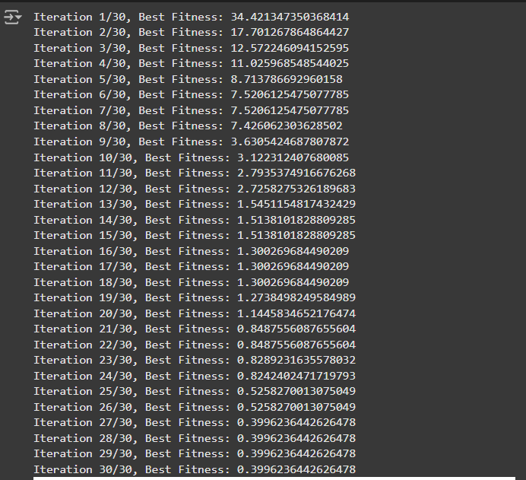

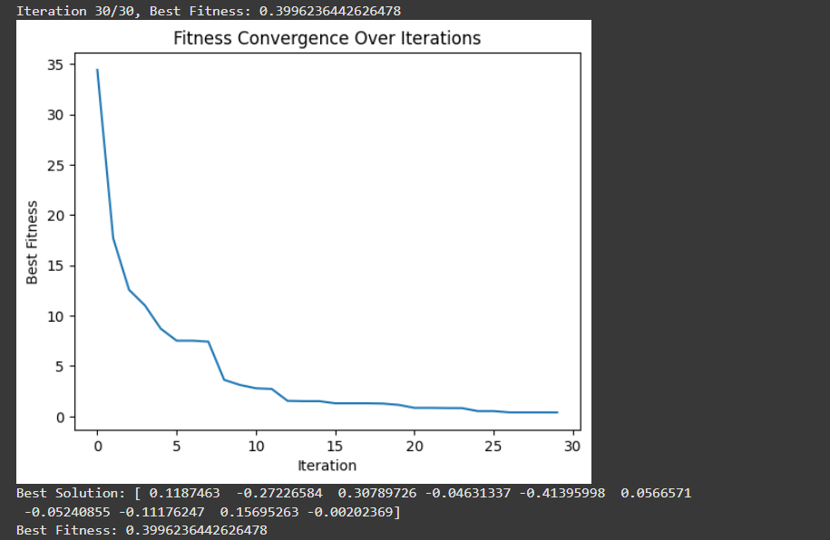

**Program 5: Grey Wolf Optimizer (GWO)**

**Algorithm:**

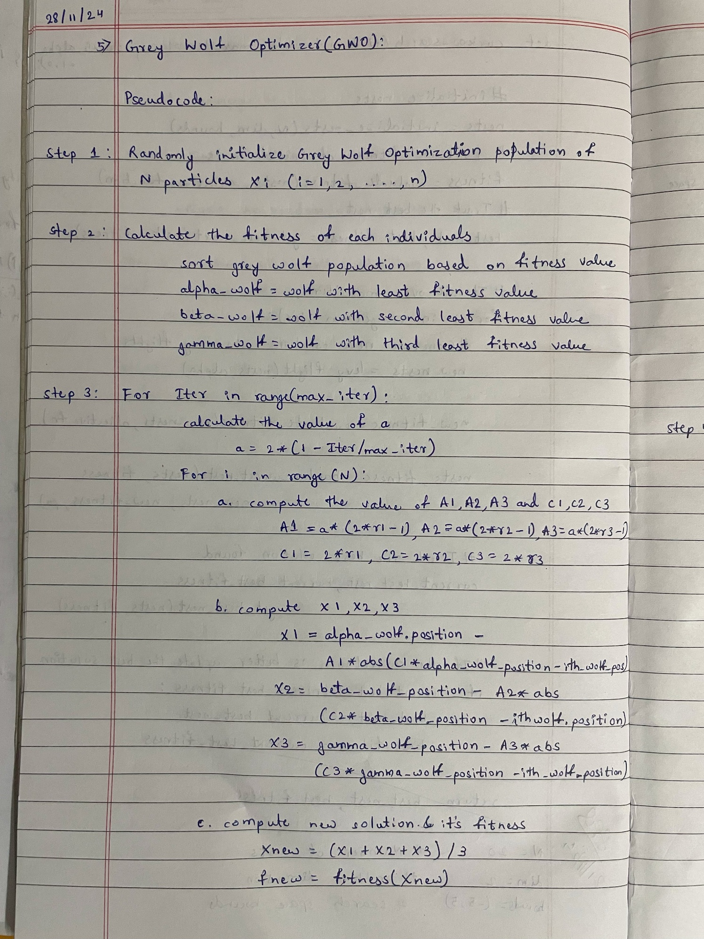

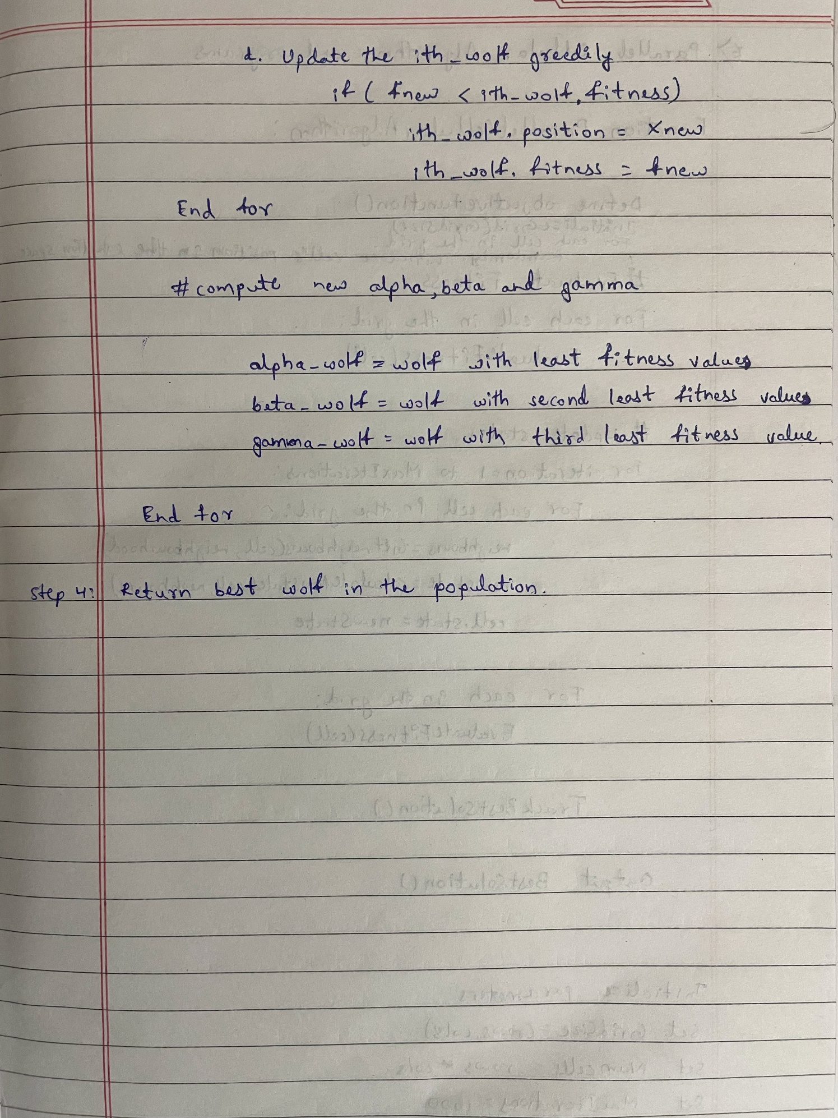

**Code:**

#GWO

import numpy as np

import matplotlib.pyplot as plt

# Step 1: Define the Problem (a mathematical function to optimize)

def objective_function(x):

    return np.sum(x**2)  # Example: Sphere function (minimize sum of squares)

# Step 2: Initialize Parameters

num_wolves = 5  # Number of wolves in the pack

num_dimensions = 2  # Number of dimensions (for the optimization problem)

num_iterations = 30  # Number of iterations

lb = -10  # Lower bound of search space

ub = 10  # Upper bound of search space

# Step 3: Initialize Population (Generate initial positions randomly)

wolves = np.random.uniform(lb, ub, (num_wolves, num_dimensions))

# Initialize alpha, beta, delta wolves

alpha_pos = np.zeros(num_dimensions)

beta_pos = np.zeros(num_dimensions)

delta_pos = np.zeros(num_dimensions)

alpha_score = float('inf')  # Best (alpha) score

beta_score = float('inf')   # Second best (beta) score

delta_score = float('inf')  # Third best (delta) score

# To store the alpha score over iterations for graphing

alpha_score_history = []

# Step 4: Evaluate Fitness and assign Alpha, Beta, Delta wolves

def evaluate_fitness():

    global alpha_pos, beta_pos, delta_pos, alpha_score, beta_score, delta_score

    for wolf in wolves:

        fitness = objective_function(wolf)

        # Update Alpha, Beta, Delta wolves based on fitness

        if fitness < alpha_score:

            delta_score = beta_score

            delta_pos = beta_pos.copy()

            beta_score = alpha_score

            beta_pos = alpha_pos.copy()

            alpha_score = fitness

            alpha_pos = wolf.copy()

        elif fitness < beta_score:

            delta_score = beta_score

            delta_pos = beta_pos.copy()

            beta_score = fitness

            beta_pos = wolf.copy()

        elif fitness < delta_score:

            delta_score = fitness

            delta_pos = wolf.copy()

# Step 5: Update Positions

def update_positions(iteration):

    a = 2 - iteration * (2 / num_iterations)  # a decreases linearly from 2 to 0

    for i in range(num_wolves):

        for j in range(num_dimensions):

            r1 = np.random.random()

            r2 = np.random.random()

            # Position update based on alpha

            A1 = 2 * a * r1 - a

            C1 = 2 * r2

            D_alpha = abs(C1 * alpha_pos[j] - wolves[i, j])

            X1 = alpha_pos[j] - A1 * D_alpha

            # Position update based on beta

            r1 = np.random.random()

            r2 = np.random.random()

            A2 = 2 * a * r1 - a

            C2 = 2 * r2

            D_beta = abs(C2 * beta_pos[j] - wolves[i, j])

            X2 = beta_pos[j] - A2 * D_beta

            # Position update based on delta

            r1 = np.random.random()

            r2 = np.random.random()

            A3 = 2 * a * r1 - a

            C3 = 2 * r2

            D_delta = abs(C3 * delta_pos[j] - wolves[i, j])

            X3 = delta_pos[j] - A3 * D_delta

            # Update wolf position

            wolves[i, j] = (X1 + X2 + X3) / 3

            # Apply boundary constraints

            wolves[i, j] = np.clip(wolves[i, j], lb, ub)

# Step 6: Iterate (repeat evaluation and position updating)

for iteration in range(num_iterations):

    evaluate_fitness()  # Evaluate fitness of each wolf

    update_positions(iteration)  # Update positions based on alpha, beta, delta

    # Record the alpha score for this iteration

    alpha_score_history.append(alpha_score)

    # Optional: Print current best score

    print(f"Iteration {iteration+1}/{num_iterations}, Alpha Score: {alpha_score}")

# Step 7: Output the Best Solution

print("Best Solution:", alpha_pos)

print("Best Solution Fitness:", alpha_score)

# Plotting the convergence graph

plt.plot(alpha_score_history)

plt.title('Convergence of Grey Wolf Optimizer')

plt.xlabel('Iteration')

plt.ylabel('Alpha Fitness Score')

plt.grid(True)

plt.show()

**OUTPUT:**

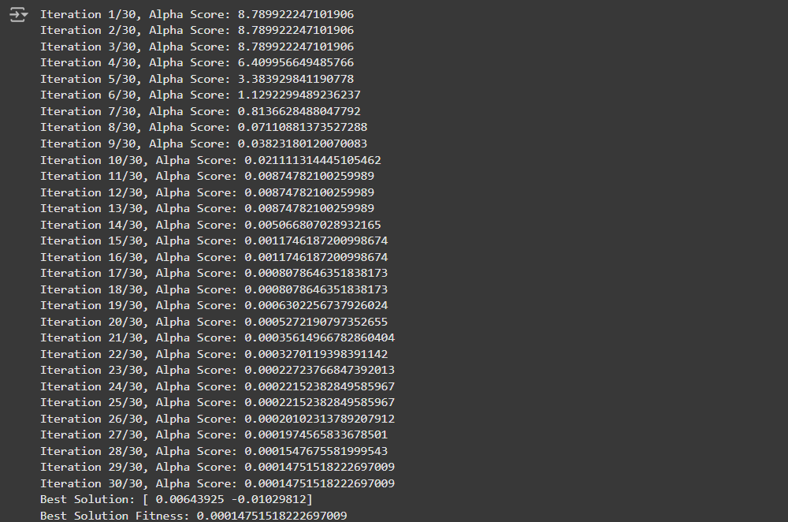

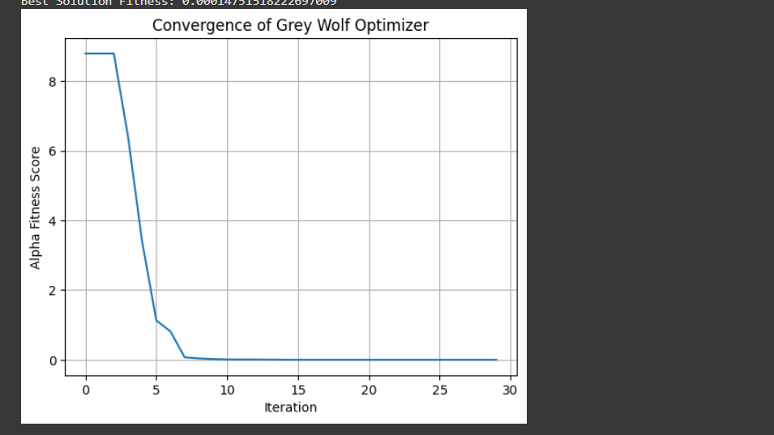

**Program 6: Parallel Cellular Algorithms and Programs**

**Algorithm:**

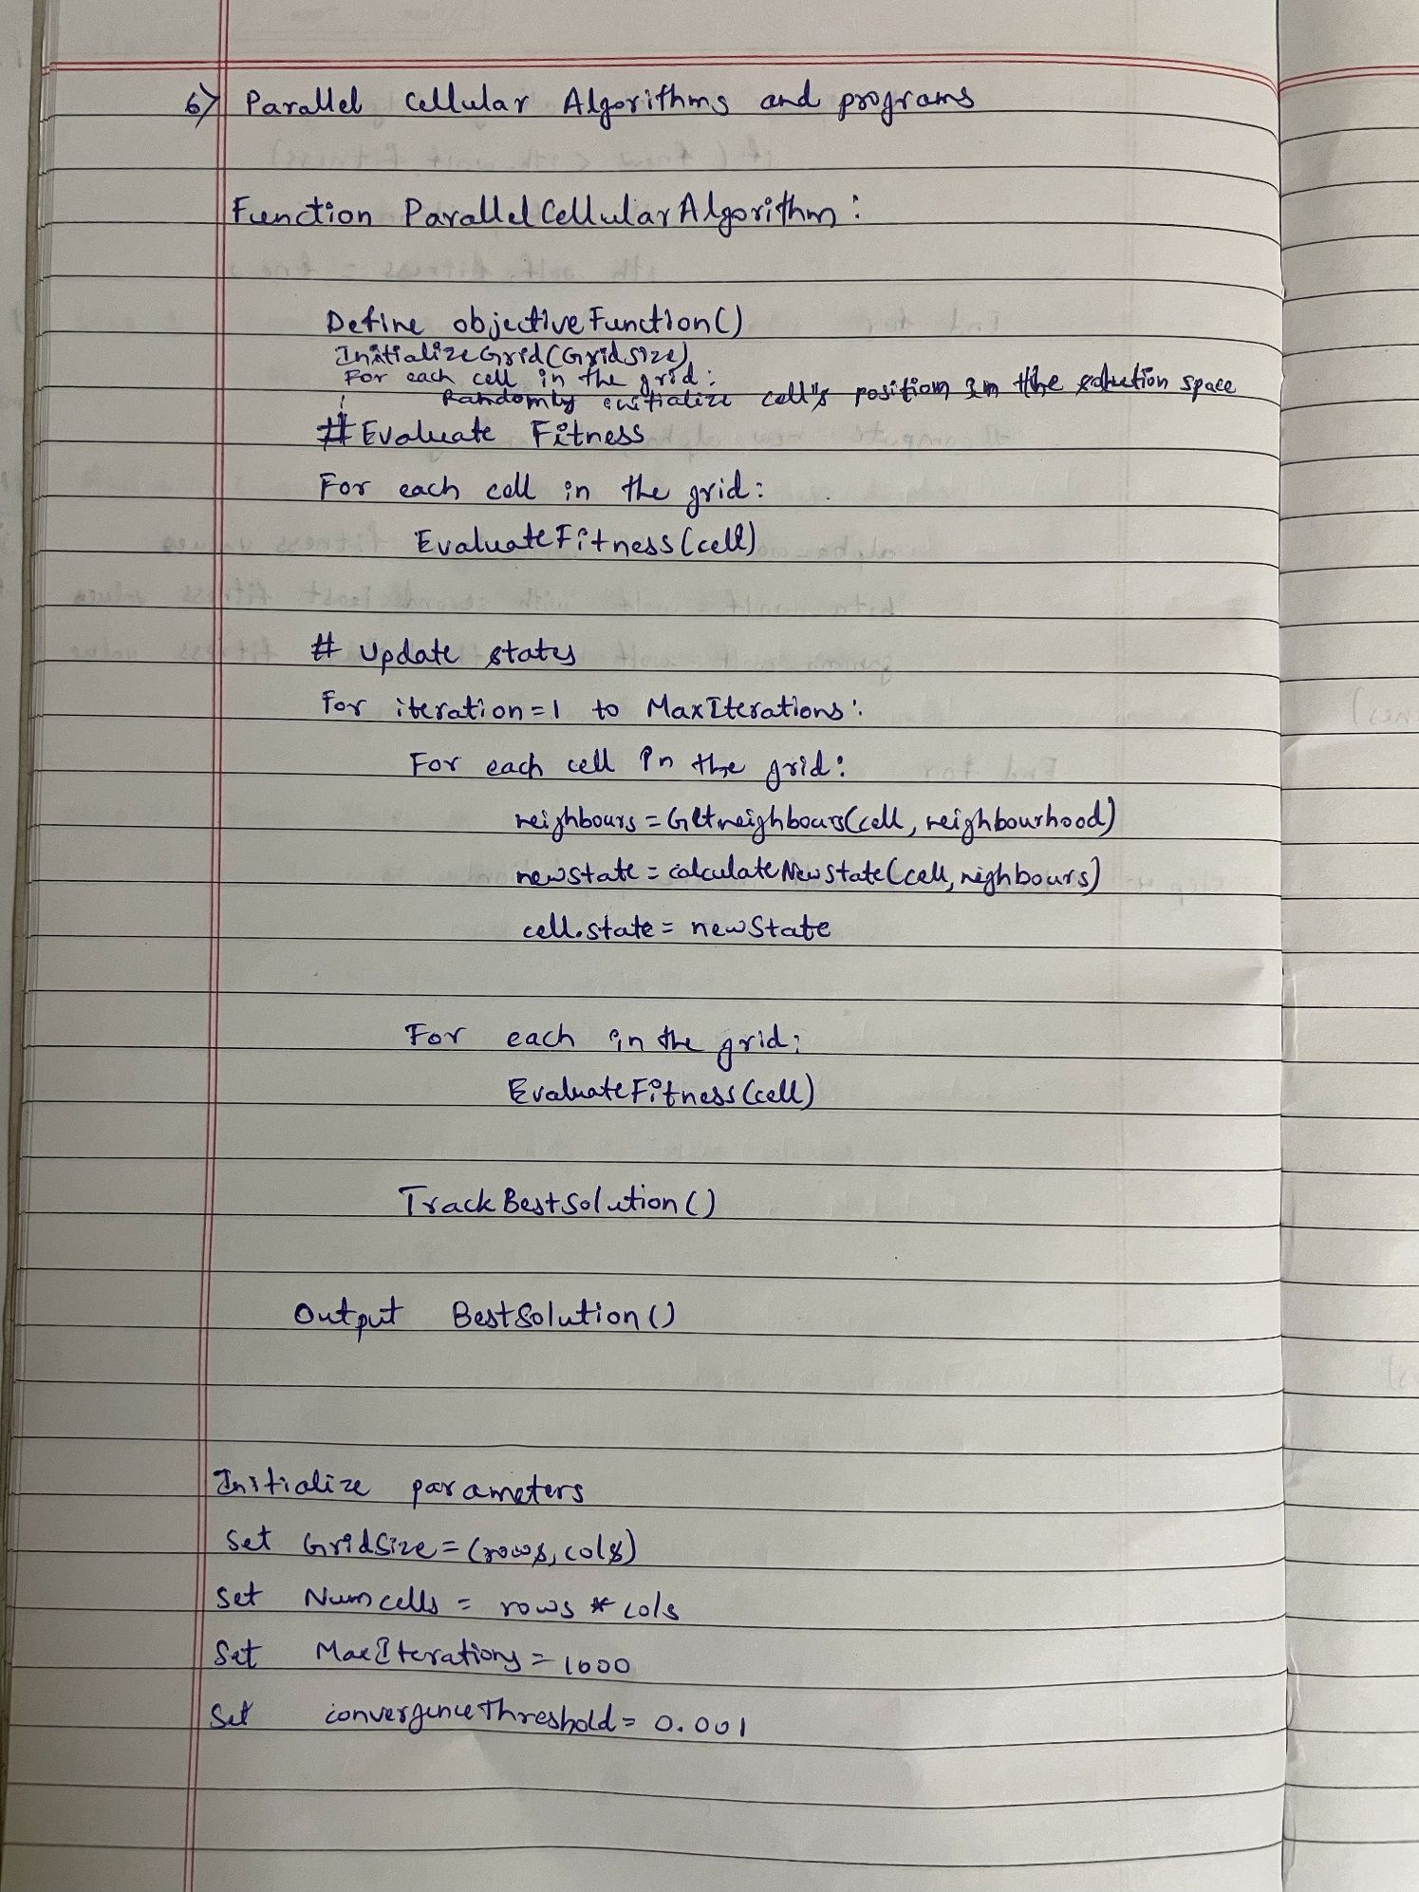

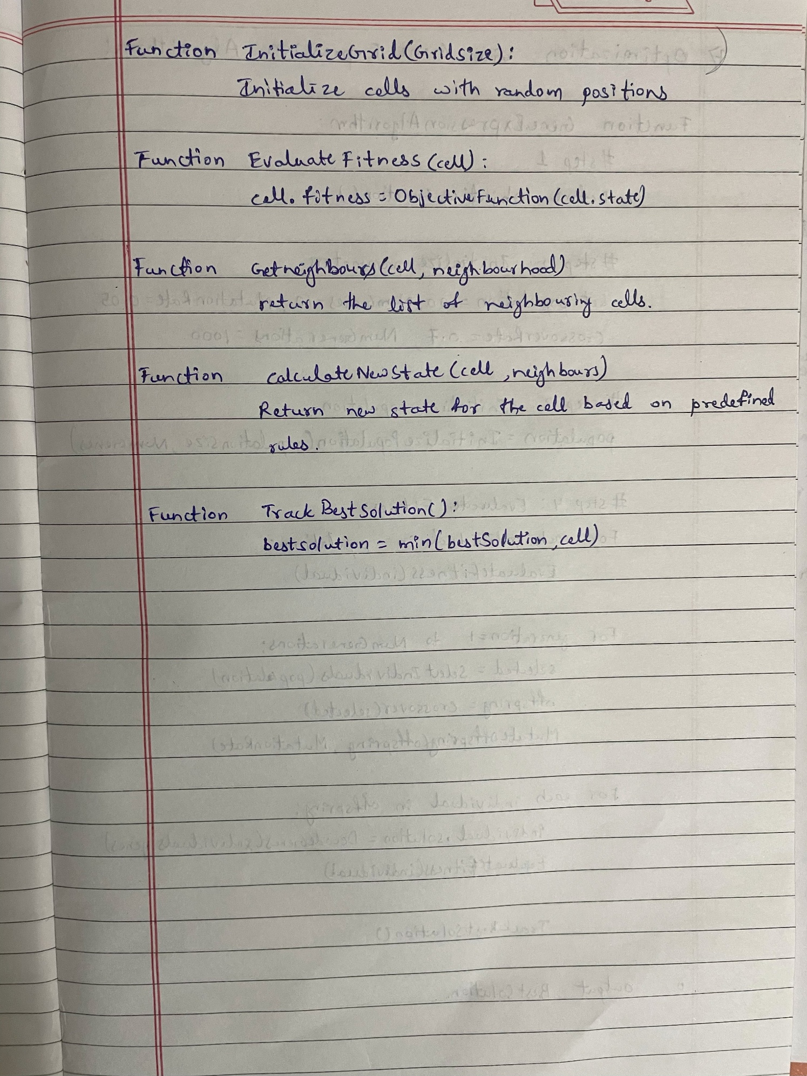

**Code:**

#pcap

import numpy as np

# Define the problem: A simple optimization function (e.g., Sphere Function)

def optimization_function(position):

    """Example: Sphere Function for minimization."""

    return sum(x**2 for x in position)

# Initialize Parameters

GRID_SIZE = (10, 10)  # Grid size (rows, columns)

NEIGHBORHOOD_RADIUS = 1  # Moore neighborhood radius

DIMENSIONS = 2  # Number of dimensions in the solution space

ITERATIONS = 30  # Number of iterations

# Initialize Population

def initialize_population(grid_size, dimensions):

    """Initialize a grid with random positions."""

    population = np.random.uniform(-10, 10, size=(grid_size[0], grid_size[1], dimensions))

    return population

# Evaluate Fitness

def evaluate_fitness(population):

    """Calculate the fitness of all cells."""

    fitness = np.zeros((population.shape[0], population.shape[1]))

    for i in range(population.shape[0]):

        for j in range(population.shape[1]):

            fitness[i, j] = optimization_function(population[i, j])

    return fitness

# Get Neighborhood

def get_neighborhood(grid, x, y, radius):

    """Get the neighbors of a cell within the specified radius."""

    neighbors = []

    for i in range(-radius, radius + 1):

        for j in range(-radius, radius + 1):

            if i == 0 and j == 0:

                continue  # Skip the current cell

            ni, nj = x + i, y + j

            if 0 <= ni < grid.shape[0] and 0 <= nj < grid.shape[1]:

                neighbors.append((ni, nj))

    return neighbors

# Update States

def update_states(population, fitness):

    """Update the state of each cell based on its neighbors."""

    new_population = np.copy(population)

    for i in range(population.shape[0]):

        for j in range(population.shape[1]):

            neighbors = get_neighborhood(population, i, j, NEIGHBORHOOD_RADIUS)

            best_neighbor = population[i, j]

            best_fitness = fitness[i, j]

            # Find the best position among neighbors

            for ni, nj in neighbors:

                if fitness[ni, nj] < best_fitness:

                    best_fitness = fitness[ni, nj]

                    best_neighbor = population[ni, nj]

            # Update the cell state (move towards the best neighbor)

            new_population[i, j] = (population[i, j] + best_neighbor) / 2  # Average position

    return new_population

# Main Algorithm

def parallel_cellular_algorithm():

    """Implementation of the Parallel Cellular Algorithm."""

    population = initialize_population(GRID_SIZE, DIMENSIONS)

    best_solution = None

    best_fitness = float('inf')

    for iteration in range(ITERATIONS):

        # Evaluate fitness

        fitness = evaluate_fitness(population)

        # Track the best solution

        min_fitness = np.min(fitness)

        if min_fitness < best_fitness:

            best_fitness = min_fitness

            best_solution = population[np.unravel_index(np.argmin(fitness), fitness.shape)]

        # Update states based on neighbors

        population = update_states(population, fitness)

        # Print progress

        print(f"Iteration {iteration + 1}: Best Fitness = {best_fitness}")

    print("\nBest Solution Found:")

    print(f"Position: {best_solution}, Fitness: {best_fitness}")

# Run the algorithm

if __name__ == "__main__":

    parallel_cellular_algorithm()

OUTPUT:

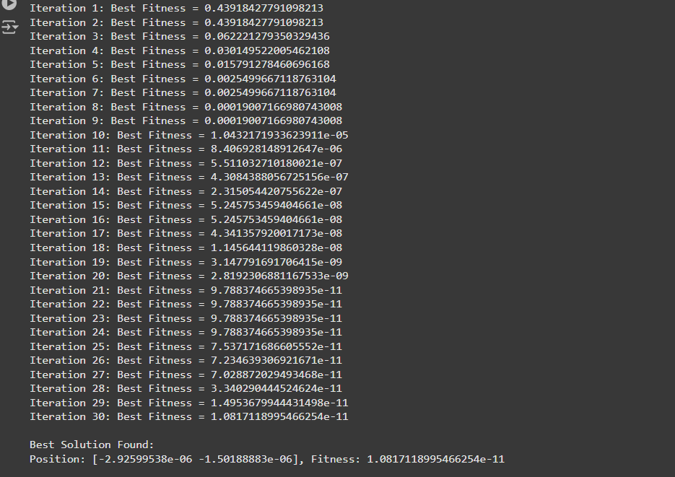

**Program 7: Optimization via Gene Expression Algorithms**

**Algorithm:**

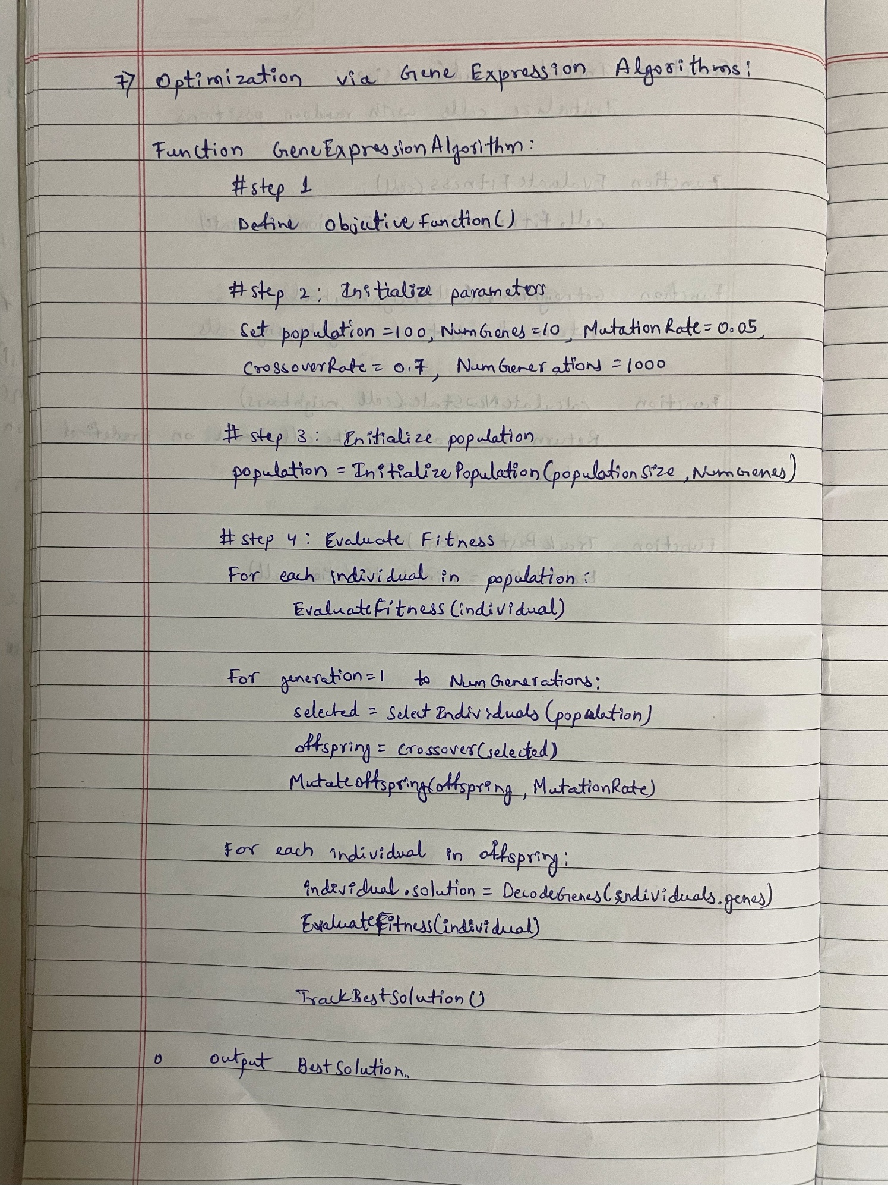

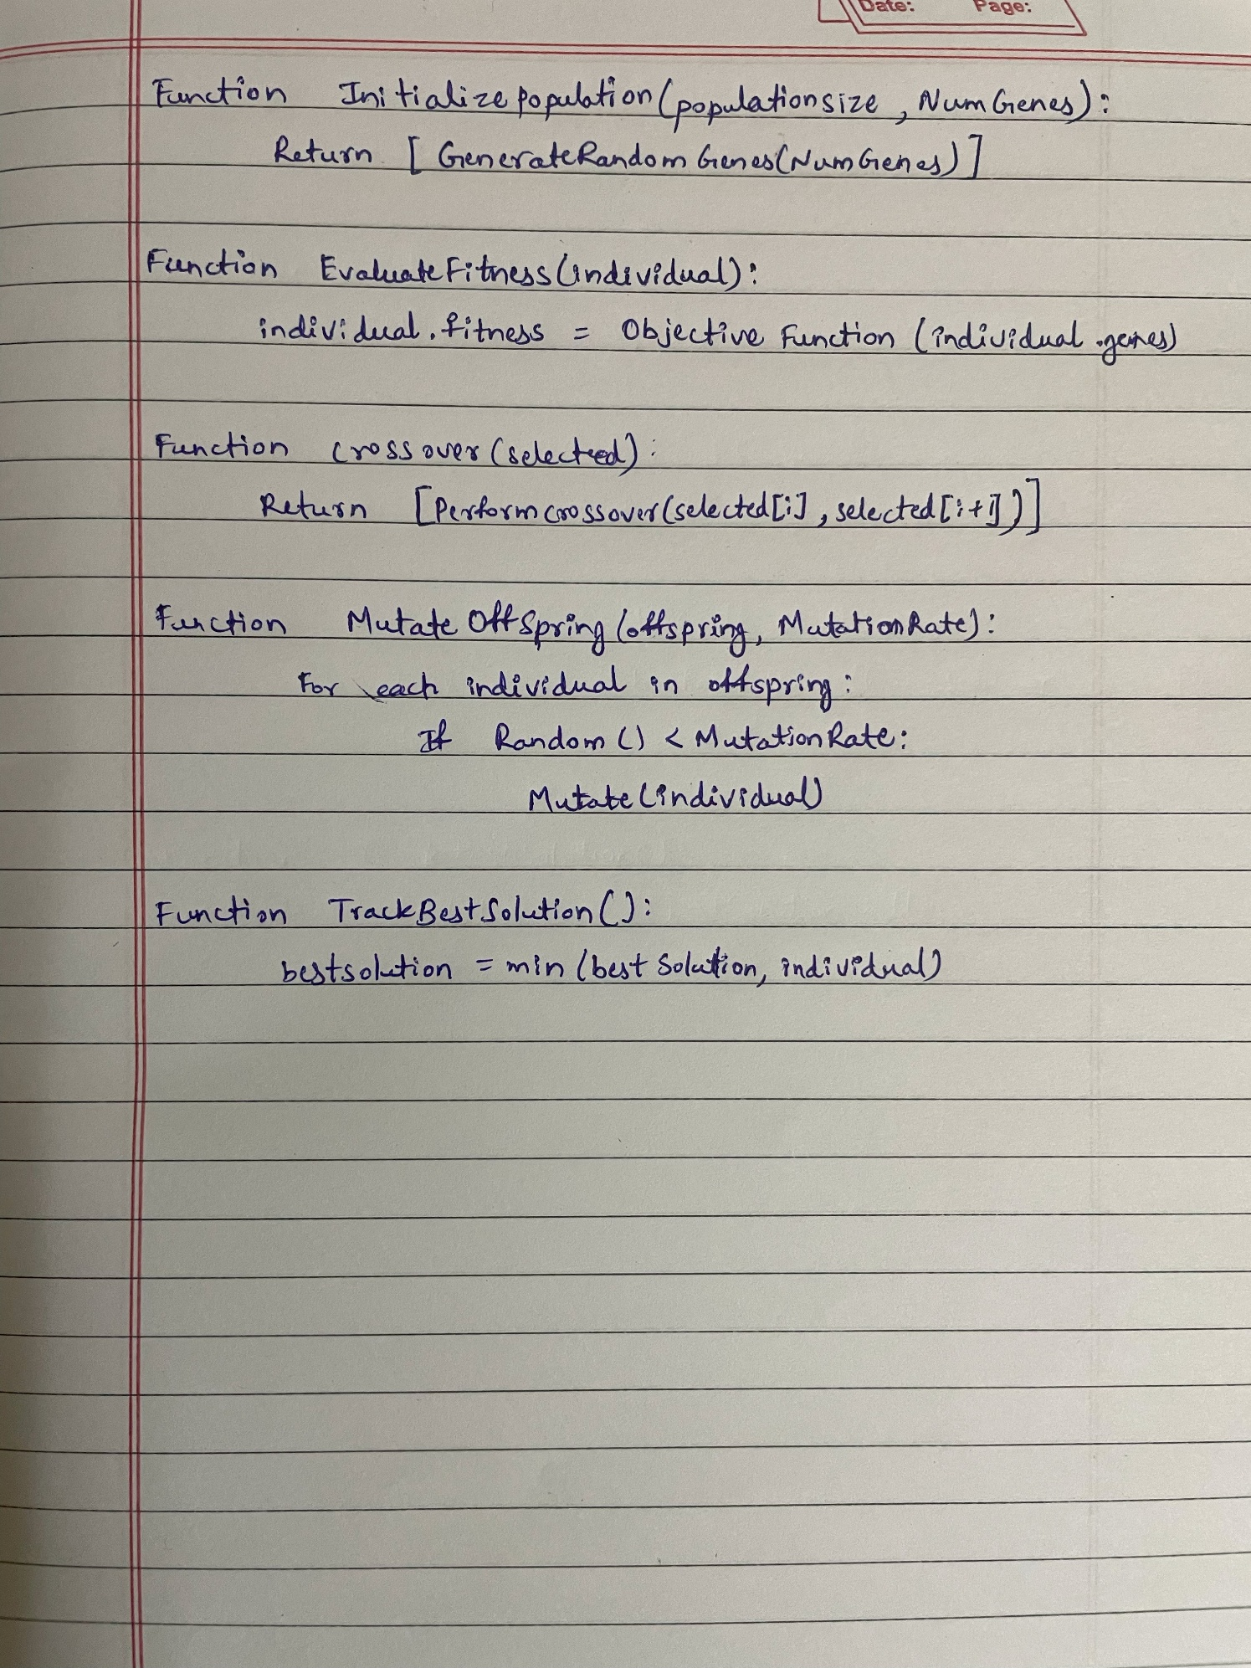

**Code:**

import numpy as np

import random

# 1. Define the Problem: Optimization Function (e.g., Sphere Function)

def optimization_function(solution):

    """Sphere Function for minimization (fitness evaluation)."""

    return sum(x**2 for x in solution)

# 2. Initialize Parameters

POPULATION_SIZE = 50  # Number of genetic sequences (solutions)

GENES = 5  # Number of genes per solution

MUTATION_RATE = 0.1  # Probability of mutation

CROSSOVER_RATE = 0.7  # Probability of crossover

GENERATIONS = 30  # Number of generations to evolve

# 3. Initialize Population

def initialize_population(pop_size, genes):

    """Generate initial population of random genetic sequences."""

    return np.random.uniform(-10, 10, (pop_size, genes))

# 4. Evaluate Fitness

def evaluate_fitness(population):

    """Evaluate the fitness of each genetic sequence."""

    fitness = [optimization_function(solution) for solution in population]

    return np.array(fitness)

# 5. Selection: Tournament Selection

def select_parents(population, fitness, num_parents):

    """Select parents using tournament selection."""

    parents = []

    for _ in range(num_parents):

        tournament = random.sample(range(len(population)), 3)  # Randomly select 3 candidates

        best = min(tournament, key=lambda idx: fitness[idx])

        parents.append(population[best])

    return np.array(parents)

# 6. Crossover: Single-Point Crossover

def crossover(parents, crossover_rate):

    """Perform crossover between pairs of parents."""

    offspring = []

    for i in range(0, len(parents), 2):

        if i + 1 >= len(parents):

            break

        parent1, parent2 = parents[i], parents[i + 1]

        if random.random() < crossover_rate:

            point = random.randint(1, len(parent1) - 1)  # Single crossover point

            child1 = np.concatenate((parent1[:point], parent2[point:]))

            child2 = np.concatenate((parent2[:point], parent1[point:]))

        else:

            child1, child2 = parent1, parent2  # No crossover

        offspring.extend([child1, child2])

    return np.array(offspring)

# 7. Mutation

def mutate(offspring, mutation_rate):

    """Apply mutation to introduce variability."""

    for i in range(len(offspring)):

        for j in range(len(offspring[i])):

            if random.random() < mutation_rate:

                offspring[i][j] += np.random.uniform(-1, 1)  # Random small change

    return offspring

# 8. Gene Expression: Functional Solution (No transformation needed for this case)

def gene_expression(population):

    """Translate genetic sequences into functional solutions."""

    return population  # Genetic sequences directly represent solutions here.

# 9. Main Function: Gene Expression Algorithm

def gene_expression_algorithm():

    """Implementation of Gene Expression Algorithm for optimization."""

    # Initialize population

    population = initialize_population(POPULATION_SIZE, GENES)

    best_solution = None

    best_fitness = float('inf')

    for generation in range(GENERATIONS):

        # Evaluate fitness

        fitness = evaluate_fitness(population)

        # Track the best solution

        min_fitness_idx = np.argmin(fitness)

        if fitness[min_fitness_idx] < best_fitness:

            best_fitness = fitness[min_fitness_idx]

            best_solution = population[min_fitness_idx]

        # Selection

        parents = select_parents(population, fitness, POPULATION_SIZE // 2)

        # Crossover

        offspring = crossover(parents, CROSSOVER_RATE)

        # Mutation

        offspring = mutate(offspring, MUTATION_RATE)

        # Gene Expression

        population = gene_expression(offspring)

        # Print progress

        print(f"Generation {generation + 1}: Best Fitness = {best_fitness}")

    # Output the best solution

    print("\nBest Solution Found:")

    print(f"Position: {best_solution}, Fitness: {best_fitness}")

# 10. Run the Algorithm

if __name__ == "__main__":

    gene_expression_algorithm()

OUTPUT:

